SRI ASNM GOVERNEMENT (A) COLLEGE,PALAKOL.

DEPARTMENT OF BOTANY

FIELD TRIP

Department of Botany conducted field visit to Dr YSR Horticulture university at Venkataramannagudem, on 24/02/2022 with 41 students and two faculty members this program succeed by different kinds of culturing systems under different varieties of fruits, vegetable crops, flowers and medicinal plants students were also seeing the harvested crops and crop materials which were grown by using the organic manure the students who were participated in the program and enriched with more knowledge about the cultivation techniques and also the benefits of medicinal plants and the use uses of organic manure to plant crop use etc they also get knowledge about the composition of manure and its importance

|  |
| --- |
| C:\Users\ASNM\Downloads\WhatsApp Image 2022-02-23 at 6.19.16 PM.jpeg |

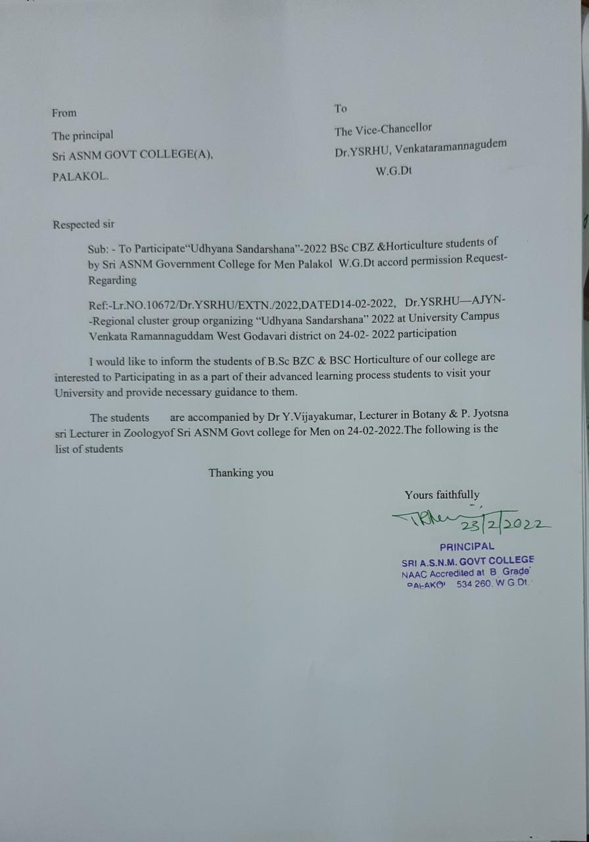

|  |  |
| --- | --- |
| C:\Users\ASNM\Downloads\WhatsApp Image 2022-02-24 at 9.28.30 PM.jpeg | C:\Users\ASNM\Downloads\WhatsApp Image 2022-02-24 at 9.28.30 PM (1).jpeg |
| C:\Users\ASNM\Downloads\WhatsApp Image 2022-02-24 at 9.28.30 PM (2).jpeg | C:\Users\ASNM\Downloads\WhatsApp Image 2022-02-24 at 9.28.30 PM (4).jpeg |
| C:\Users\ASNM\Downloads\WhatsApp Image 2022-02-24 at 9.28.30 PM (5).jpeg | C:\Users\ASNM\Downloads\WhatsApp Image 2022-02-24 at 9.28.30 PM (6).jpeg |
| C:\Users\ASNM\Downloads\WhatsApp Image 2022-02-24 at 9.28.30 PM (7).jpeg | C:\Users\ASNM\Downloads\WhatsApp Image 2022-02-26 at 3.12.51 PM (1).jpeg |
| C:\Users\ASNM\Downloads\WhatsApp Image 2022-02-26 at 3.12.52 PM.jpeg | C:\Users\ASNM\Downloads\WhatsApp Image 2022-02-26 at 3.12.51 PM.jpeg |